1080p gaming Webcam MIC Driver free computer camera PC laptop Full HD Web Camera Video Call Meeting Broadcast Live streaming
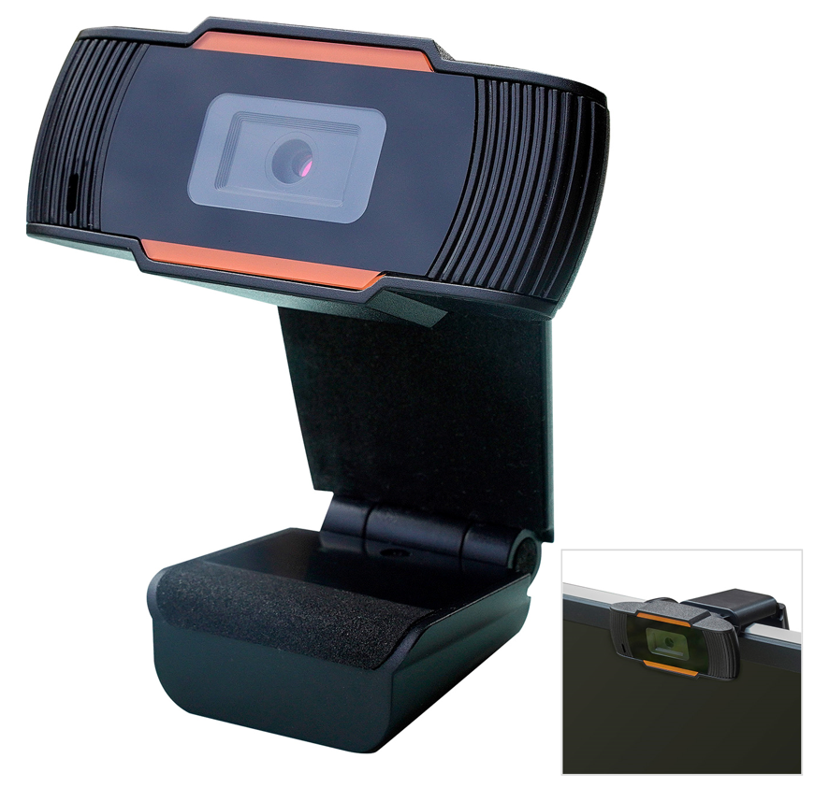

Introduction:
Built-in microphone, your voice can be heard clearly in 10 meters.
2.Great quality and exquisite appearance.
3.The head can be rotated freely up and down 85 degrees, and the angle can be easily adjusted
4.Specialized optical lens, high precision.
5.Designed for both laptop and desktop.
6.Auto white balance, auto color correction.
7.Manual adjustable focal length.

Specification
Product Name | webcam
Image Sensor | High Definition Color CMOS Sensor
pixels | 2 million pixels
Resolution | 1920*1080
Audio | Build-in Sound absorption and noise reduction microphone
USB interface | USB2.0 USB 3.0 Driver free(plug and play)
Working voltage | DC5V
System compatibility | Windows XP、 Windows Vista、Windows 7、Windows 8.1 、Windows 10, Mac OS , Android5.0 and above ,Linux,Chrome OS,XBOX one,ubuntu
APP compatibility | ZOOM,Youtube,Skype,Google meet,Microsoft Teams,Twitter,Yahoo!@Messenger,MSN,Windows Live@Messager,Gmail,Facebook Live,XBOX One,  ClickMeeting,Twitch,Mixer,XSplit,GoToMeeting,Google Hangouts,Team viewer,Face time,Welink,join.me,Zoho,Live Size,WeChat,Ding Talk

